**Will my child be part time to begin with/have a staggered start?**

After home visits and induction days are completed all children will officially start school on 14th September. We believe in hitting the ground running and we offer the vast majority of our children a full time place at our school from day 1.

Occasionally, where there are special circumstances, a mutual arrangement may be made between school and parents to stagger a child’s start date or to offer a part time place for a short time.

**What will children wear to school and is the uniform compulsory?**

School uniform will be compulsory for all at our school and comprises a white polo shirt with logo, purple sweatshirt with logo, grey trousers, smart shorts or skirt, black/white socks or tights and black shoes.

Children in Reception may also spend a lot of their day outside, so outdoor clothing to suit the weather conditions is also essential.

**What about PE?**

Children have access to an outside area every day and much of their physical development takes place within the Reception learning environment.

Children also have a PE session once a week where they will take part in gymnastics, dance or team games. From January we expect all children to change for PE lessons and a full kit, including plimsolls must be provided.

**How do I apply for a place?**

Our admissions are administered by Waltham Forest Local Authority.

Late applications must be made in person.

[](http://www.walthamstowprimaryacademy.org.uk/)

**Frequently asked questions**



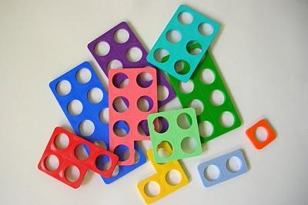



[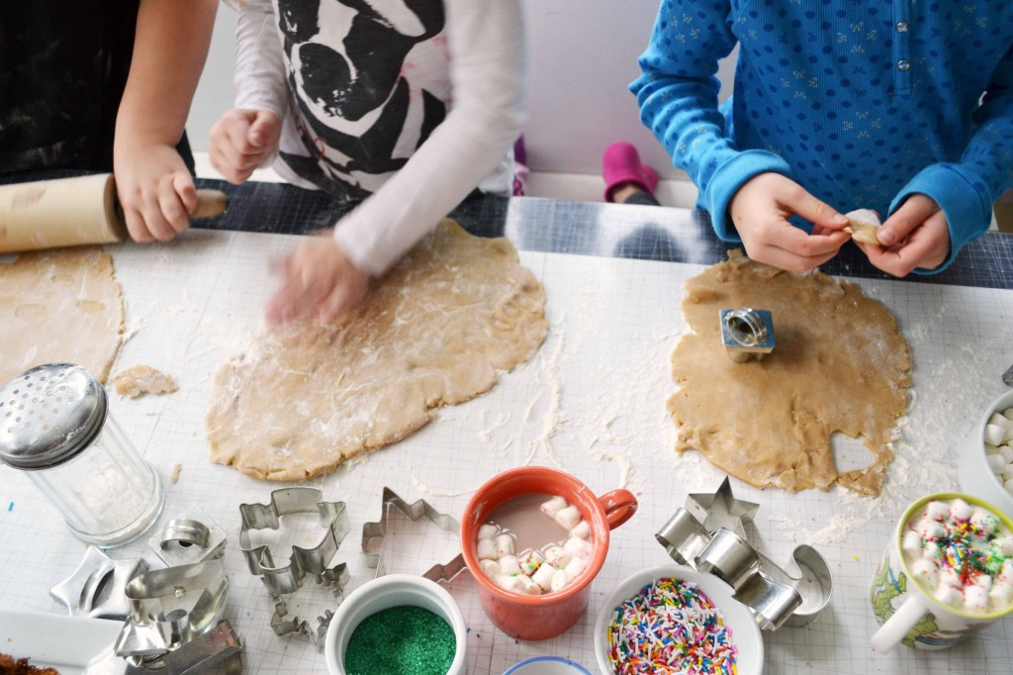](http://cookery-ideas.co.uk/?attachment_id=1790)

**Are school meals free for everybody?**

Yes. School meals for all infant-aged children (Reception to Year 2) are funded by the government. There is no need to make an application for free school meals, but families whose income falls below a certain level should still put in an application to ensure the school receives additional funding (over £1000 per year) to support their children’s education.

**How will lunchtimes arranged?**

Initially meals will be cooked by the secondary school and we will make use of their dining facilities (at a separate time from the secondary aged children). When we move to our permanent building meals will be cooked on-site and eaten in our own school halls.

**Are the teachers fully qualified?**

Yes, all class teachers have a teaching qualification.

**How are children assessed?**

Teachers continually observe and note what children can do and use this as a basis to plan for their next steps. At the end of the year each child’s attainment is recorded against the EYFS Profile. We encourage parents to contribute to the assessment process.

**What is the ratio of adults to children?**

We will ensure that the ratio in our Reception Classes is at least 1:15.

**How many children will there be in each class?**

Each class has up to 30 children. There are two classes in the Reception unit, meaning there is provision for up to 60 children.

**How will you teach reading and writing?**

We will use a phonics scheme called Read Write Inc. to teach children the sounds of the letters of the alphabet, and a puppet called Fred helps them to ‘blend’ sounds together to read words and ‘segment’ whole words to help spell them. Look out for our Family Learning Event on phonics!

**Will you provide wrap-around care?**

Yes. Details are yet to be finalised and we are in discussion with a number of providers with a view of ensuring best value for money for our families. We expect the extended day to run from 7.30am to 6pm

**What after-school clubs and activities will you offer?**

Our teachers and support staff are committed to offering a wide variety of lunchtime and after-school activities and the programme will change throughout the year, and may include football, science, singing, needlework, games and puzzles, eco-warriors, ICT and dance.

The provision of lunchtime and after-school activities will become available after the Christmas break once the children have had plenty of time to settle into school life.

**What will my child learn in Reception?**

We follow the Early Years Foundation Stage Curriculum, which has play-based, experiential learning at its heart. Through well-planned and targeted activities and experiences, children develop knowledge, skills and competencies across 7 areas of learning – Personal, Social and Emotional Development, Language and Communication, Physical Development, Literacy, Mathematics, Understanding the World and Expressive Arts and Design.